# ..\..\Bilder\LOGO\Kunststoffe\KURO_Logo.gif

###### KURO – Information for invitation to tender

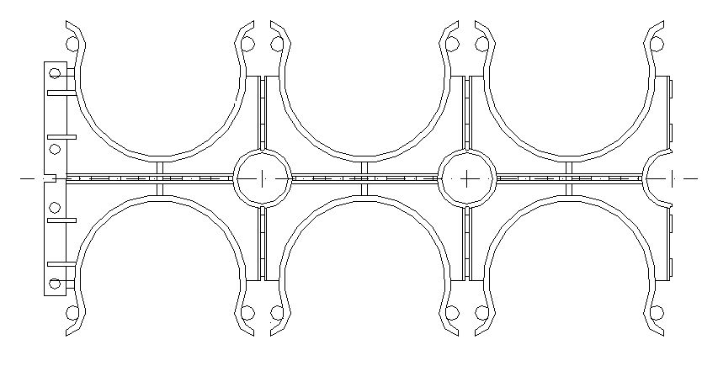

**Product:**

#### PP Spacers 6 – lined

**For corrugated pipe**

# Information for invitation to tender:

|  |  |  |
| --- | --- | --- |
|  | Pos:....................... | PP Spacers for corrugated pipe double sided for 110 mm |
|  |  | Cable protection pipe / 6-lined / System KURO o. glw. |
|  |  | (www.kuro-kunststoffe.de), supply and install, |
|  |  | as an addition to pos: ........... |
|  |  |  |
|  |  | Amount:............Pieces UP: ....... TP: ........ |

|  |  |  |
| --- | --- | --- |
|  | Pos:....................... | PP Spacers for corrugated pipe double sided for 125 mm |
|  |  | Cable protection pipe / 6-lined / System KURO o. glw. |
|  |  | (www.kuro-kunststoffe.de), supply and install, |
|  |  | as an addition to pos: ........... |
|  |  |  |
|  |  | Amount:............Pieces UP: ....... TP: ........ |

|  |  |  |
| --- | --- | --- |
|  | Pos:....................... | PP Spacers for corrugated pipe double sided for 160 mm |
|  |  | Cable protection pipe / 6-lined / System KURO o. glw. |
|  |  | (www.kuro-kunststoffe.de), supply and install, |
|  |  | as an addition to pos: ........... |
|  |  |  |
|  |  | Amount:............Pieces UP: ....... TP: ........ |

|  |  |  |
| --- | --- | --- |
|  |  |  |
|  |  |  |
|  |  |  |
|  |  |  |
|  |  |  |
|  |  |  |

H:\Bilder\LOGO\Kunststoffe\Punkt_Kuro_Kunstst.gif